**Spheres**

Multiple Choice

1. Recall what the biosphere contains.
2. All of the planet's water
3. The ozone layer
4. All of the planet's living organisms
5. The Earth's crust and soils
6. State the components of the hydrosphere.
7. The earth’s oceans and rivers
8. The earth’s icebergs
9. The earth’s rainfall.
10. All of the above.
11. State the components of the atmosphere.
12. All the gases above Earth’s surface.
13. Clouds, rain and gases
14. All the living things on Earth.
15. All the water on Earth’s surface.
16. Recall which of the following options are not part of the lithosphere.
17. Soil
18. Grass
19. Mountains
20. Rocks
21. The Earth is comprised of four spheres: the atmosphere, the lithosphere, the biosphere and the hydrosphere.

This picture contains the sea and seaweed. Identify the two spheres that these things are present in.

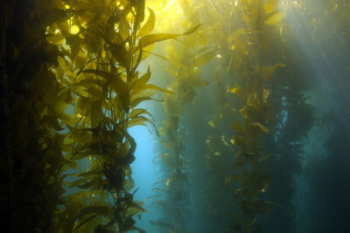

1. Hydrosphere and biosphere
2. Hydrosphere and lithosphere
3. Atmosphere and lithosphere
4. Atmosphere and hydrosphere
5. The Earth is comprised of four spheres: the atmosphere, the lithosphere, the biosphere and the hydrosphere.

This picture contains the sea and the sky. Identify the two spheres that these things are present in.

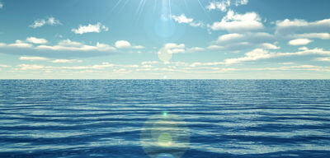

1. Atmosphere and biosphere
2. Atmosphere and lithosphere
3. Atmosphere and hydrosphere
4. Hydrosphere and biosphere
5. The Earth is comprised of four spheres: the atmosphere, the lithosphere, the biosphere and the hydrosphere.

This picture contains an animal and dirt. Identify the two spheres that these things are present in.

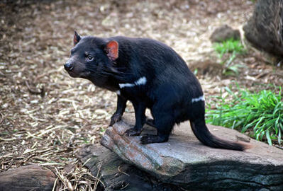

1. Biosphere and lithosphere
2. Biosphere and atmosphere
3. Lithosphere and atmosphere
4. Atmosphere and hydrosphere
5. Specify the two atmospheric layers that the ozone layer sits between.
6. Thermosphere and mesosphere
7. Stratosphere and troposphere
8. Stratosphere and thermosphere
9. Stratosphere and mesosphere
10. State the components of the ozone molecule.
11. One oxygen atom and two hydrogen atoms
12. Three oxygen atoms
13. Two oxygen atoms
14. Two oxygen atoms and one nitrogen atom
15. Recall the physical state of ozone.
16. A solid
17. A layer of clouds
18. A liquid
19. Gas
20. Describe the impact of pollutants on the ozone layer.
21. Degraded it so it disappeared completely
22. Caused it to move further away.
23. Made it thicker
24. Degraded it and formed a hole.
25. Ozone is a very reactive gas.

Recall which of the following reacts with ozone.

1. Bromine
2. Chlorine
3. Hydrogen
4. All of the above

Fill in the blanks

1. Use the following words to fill in the gaps.

**lithosphere, glaciers, hydrosphere, water, rocks**

The Earth’s ________________ is made up of all the ______________ on our planet. This includes all of the salt water oceans, fresh water lakes, _______________ and underground deposits.

The ______________ includes all ________________ and geological structures on which life exists such as soil rocks and mountains.

1. Use the following words to fill in the gaps.

**stratosphere, reducing, earth’s surface, absorb**

The role of the ____________ is to _____________ the UVB radiation from the sun ____________ the amount of UVB radiation making contact with the ____________.

1. Use the following words to fill in the gaps.

**atmosphere, biosphere, stable, gases, weather, sun, unstable**

The _____________ contains all the _____________ above Earth. Parts of the atmosphere contain the _____________ and greenhouse gases that keep Earth’s temperatures _____________.